Restricted Banking-Only Question Handling & Controlled Ollama Integration

1. Introduction
Currently, BankBot AI uses the Ollama LLM as a fallback mechanism when a user query does not match predefined FAQs. Since Ollama behaves like a general-purpose language model (similar to ChatGPT), it may generate responses for non-banking-related questions, which is undesirable in a banking application.
To address this limitation, a restricted banking-only question library is introduced to ensure that:
BankBot responds only to banking-related queries
Ollama is prevented from answering out-of-scope questions
The chatbot remains domain-specific, safe, and professional

2. Problem with Unrestricted LLM Responses
Without restrictions, Ollama may answer questions such as:
“Who is the Prime Minister of India?”
“Tell me a joke”
“What is artificial intelligence?”
“Write Python code”
This behavior:
Breaks the banking context
Reduces system credibility
Can cause compliance and security concerns in real banking environments

3. Need for Restriction

Unrestricted AI models are capable of answering a wide range of questions, including general knowledge, programming, entertainment, and other non-related topics. Such behavior is inappropriate and unsafe for banking applications. Allowing responses beyond the banking domain can lead to compliance violations, security risks, and reduced trust in the system. Therefore, restricting the chatbot strictly to banking-related queries is essential.

Advantages
• Improved security
• Domain accuracy
• Faster performance
• Regulatory compliance

4. Banking-Specific Knowledge Base
A controlled banking knowledge base defines what topics BankBot is allowed to answer.

Examples of Allowed Banking Domains
Loan Plans
Account Opening
ATM / Cash Issues
Card Blocking
Bank Timings
Net Banking
Fixed Deposit (FD)
Recurring Deposit (RD)
Interest Rates
KYC
Customer Support
This ensures the chatbot’s scope is clearly bounded.

5. Banking Keyword Validation Mechanism
Before sending any user query to Ollama, the system validates whether the query belongs to the banking domain.

Sample Banking Keywords
banking_keywords = [
"loan", "account", "atm", "card", "deposit", "fd", "rd",
"interest", "bank", "cheque", "net banking", "upi",
"transaction", "balance", "statement", "kyc", "branch"
]

Validation Logic
def is_banking_query(user_text: str) -> bool:
text = user_text.lower()
return any(keyword in text for keyword in banking_keywords)

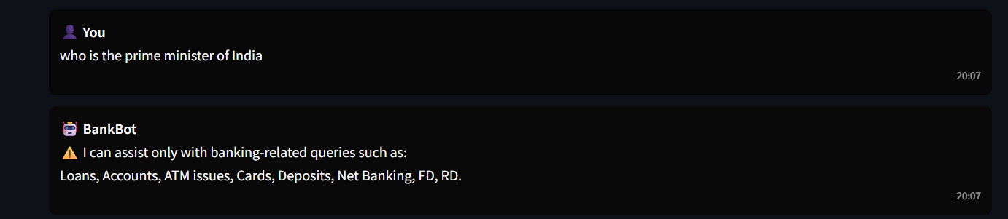

6. Controlled Ollama Usage (Key Enhancement)

Previous Behavior
Ollama answered any type of question

New Behavior
Ollama is called only if:
FAQ does not match
Query passes banking validation

Updated Decision Flow
if faq_match_found:
return faq_answerelif is_banking_query(user_text):
return ask_ollama(banking_prompt)else:
return restricted_message

7. Banking-Only Prompt Engineering
Even when Ollama is called, the prompt is strictly controlled to enforce banking-only behavior.

Restricted Prompt Example
prompt = f"""
You are BankBot, a banking assistant.
Answer ONLY banking-related questions.
If the question is not related to banking, reply with:
"I can assist only with banking-related queries."

User Question: {user_text}
This prevents the LLM from drifting outside the domain.

8. Safe Fallback Message for Non-Banking Queries
If a user enters a non-banking query, the chatbot responds safely:

Standard Restricted Response
I can assist only with banking-related queries such as loans, accounts,
ATM issues, cards, deposits, and net banking.
This ensures:
No hallucinated answers
Clear user guidance
Professional tone

9. Benefits of Restricted Question Library

Security
Prevents misuse of chatbot for unrelated or harmful queries.

Domain Accuracy
Keeps responses focused only on banking.

Industry Compliance
Aligns with real-world banking chatbot standards.

Performance
Reduces unnecessary LLM calls.

Better User Experience
Users clearly understand what the chatbot can and cannot do.

10. Updated System Flow (with Restriction)
User Input
│
▼
FAQ Match?
│ YES → Return FAQ Answer
│
▼ NOIs Banking-Related?
│ YES → Send Restricted Prompt to Ollama
│
▼ NOShow Banking-Only Restriction Message

11. Future Enhancements
Vector database (FAISS) for banking documents
Fine-tuned banking-specific LLM
Role-based question filtering (Customer vs Staff)
Regulatory compliance rules (RBI / KYC policies)

12. Conclusion
By implementing a restricted banking-only question library, BankBot AI becomes a safe, professional, and domain-focused chatbot. This enhancement ensures that Ollama is used responsibly and aligns the chatbot with real banking industry requirements.

.

